**Niemeyer, Oscar (1907-2012)**

Michael Johnson, Northumbria University

**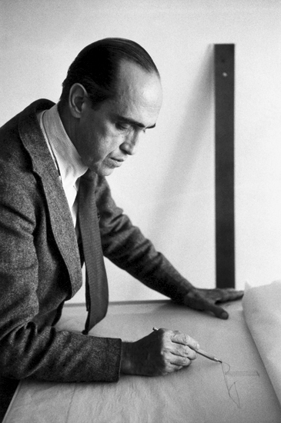**

**Oscar Niemeyer**

<http://www.phaidon.com/resource/reneburri-432.jpg>

Oscar Ribeiro de Almeida Niemeyer Soares Filho, better known as Oscar Niemeyer, was a prolific Brazilian architect and one of the leading Latin American exponents of international modernism. Like Le Corbusier, whom he admired, he explored the aesthetic possibilities of reinforced concrete, but used the plasticity of the medium to transcend the rigid dogmatism of European modernism, while evoking elements of the Brazilian landscape. His reputation rests primarily on the ceremonial buildings he created for the utopian capital of Brazil, but at the time of his death in 2012 he had completed approximately 600 works throughout the Americas, Africa, and Europe.

Niemeyer attended the National School of Fine Arts in [Rio de Janeiro](http://www.archdaily.com/tag/rio-de-janeiro/" \t "_blank) from 1929 to 1934. He worked in the office of the influential Brazilian architect and urban planner Lúcio Costa in 1932, a professional partnership that would last decades and result in many important works of modern architecture. From 1936-43 Niemeyer was a member of the team of Brazilian architects working with Le Corbusier on the new building for the Ministry of Education and Health in Rio de Janeiro. At the age of 29, he was assigned as a draftsman for Le Corbusier, but the changes he introduced after Le Corbusier’s departure convinced Costa to appoint him as the project's lead architect. The building, a horizontal bar bisected by a vertical slab, became an icon of Brazilian architecture and attracted international recognition.

Working with Costa, Niemeyer co-designed the Brazilian Pavilion for the New York World’s Fair of 1939. His distinctive talents became evident in his designs for Pampulha, a planned suburb north of Belo Horizonte (1940-43), masterminded by the city’s mayor and future President of Brazil, Juscelino Kubitshek. Niemeyer’s church of St Francis of Assisi represented a new approach to architecture, consisting of parabolic vaults. His casino, despite its relatively rigid main façade, departed from Corbusian principles and expressed curved volumes beyond the confines of the rational grid. Niemeyer also developed Le Corbusier's concept of the *promenade architecturale* with his designs for floating catwalks that embraced vistas of the surrounding landscape. These buildings received international acclaim during the *Brazil Builds* exhibition at the Museum of Modern Art in New York (1943).

Niemeyer’s expressive and highly sculptural style echoed Le Corbusier’s work of the post-war period. A clear departure from the extreme rationalism of earlier modernist architecture, this liberated idiom was eminently suitable for Brazil, with its rich legacy of Baroque buildings. In his writings, Niemeyer articulated his desire to unite Brazil's traditional colonial architecture with modernist principles. The liberated curves of his work recalled the country’s Baroque churches, as well as natural elements. As Niemeyer wrote in his memoirs:

I am not attracted to straight angles or to the straight line, hard and inflexible, created by man. I am attracted to free-flowing, sensual curves. The curves that I find in the mountains of my country, in the sinuousness of its rivers, in the waves of the ocean, and on the body of the beloved woman. Curves make up the entire Universe, the curved Universe of Einstein. (Niemayer *Curves of Time* 62 and 169–70).

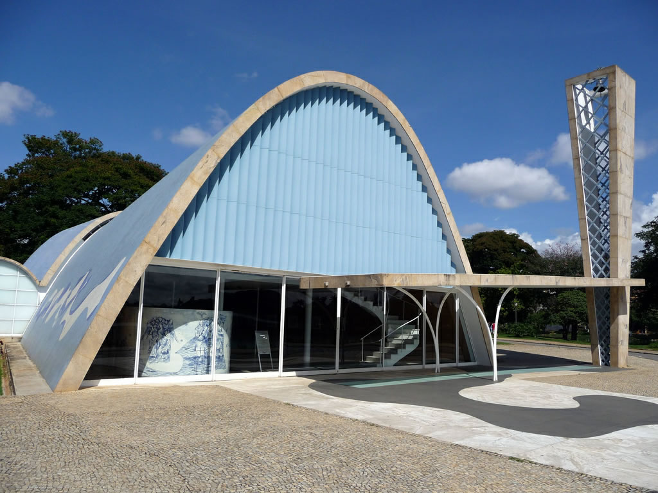

Church of Saint Francis of Assisi (1940)

<http://assets.dwell.com/sites/default/files/2014/04/24/1_st_francis_church_pampulha_architectural_complex_belo_horizonte_brazil_oscar_niemeyer.jpg>

In 1956, Brazil’s president Juscelino Kubitshek invited Niemeyer to participate in the largest urban project in the country's history: the construction of Brasília, a new capital in the middle of the savannah and far from any existing cities. Niemeyer became the architectural adviser - then chief architect - to Nova Cap, the organization responsible for designing the city. Lúcio Costa designed the masterplan using the language of international modernism. This collaboration produced the first major city in the world designed entirely on the basis of modernist principles of functionality, spatial zoning and aesthetics. The climax of the masterplan is the Square of the Three Powers, which forms a spectacular setting for Niemeyer’s National Congress of Brazil and [Supreme Federal Court](https://en.wikipedia.org/wiki/Supreme_Federal_Court), with their abstract sculptural forms and ceremonial grandeur. The slab blocks of the various ministries recall the monumentality of totalitarian architecture, but nonetheless form an impressive abstract composition along the Eixo Monumental (Monumental Axis).

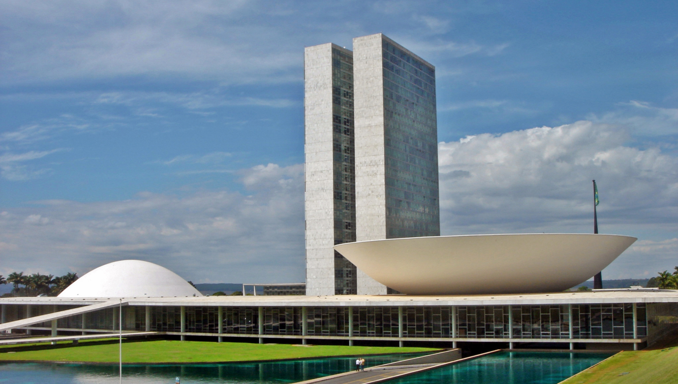

National Congress of Brazil (1958)

[www.copa2014.gov.br](http://www.google.co.uk/url?sa=i&rct=j&q=&esrc=s&source=images&cd=&cad=rja&uact=8&ved=0CAYQjB1qFQoTCIXfk8Lw9sgCFUK6FAodqCQFuQ&url=http%3A%2F%2Fwww.copa2014.gov.br%2Fes%2Fgaleria%2Fbrasiliaturismoabril2013&psig=AFQjCNE8rYWlBF2pFc8DhNDQB1bAhXdHzA&ust=1446730223584500)

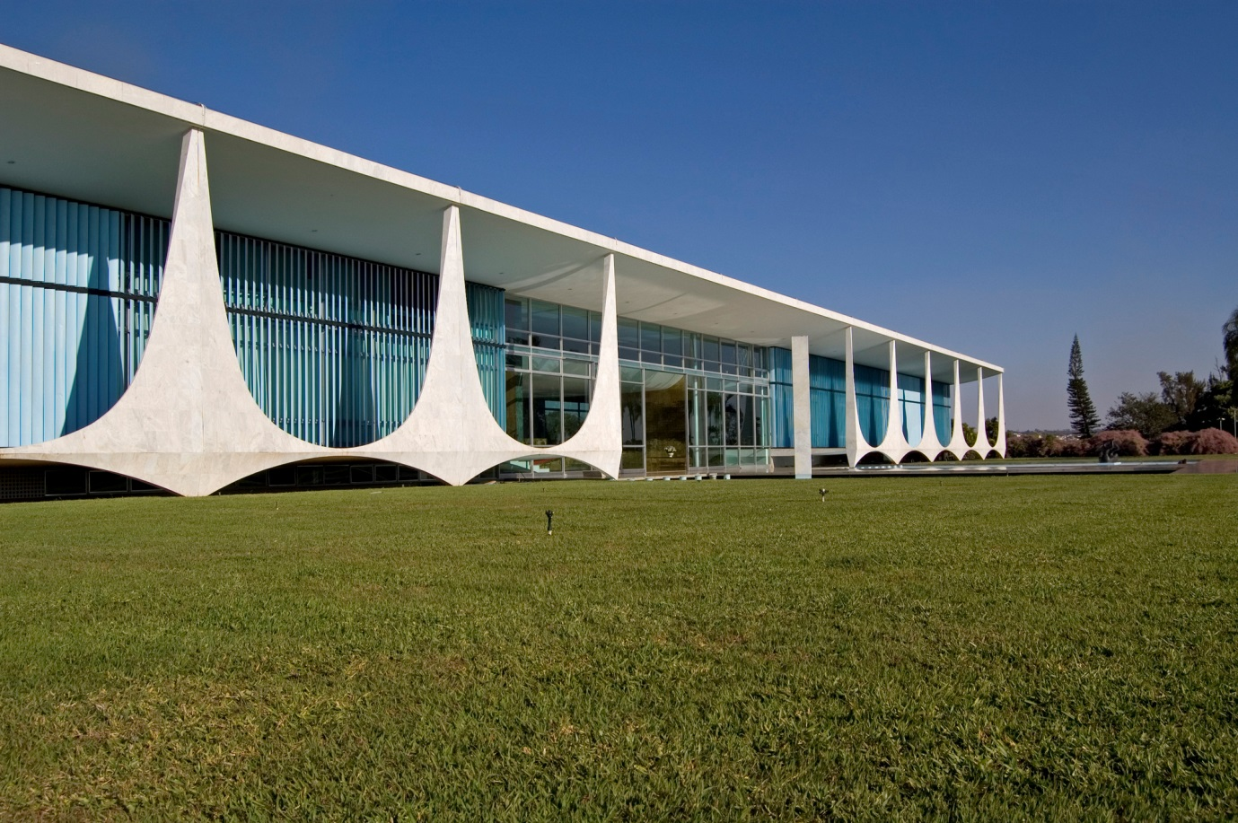

Palácio da Alvorada, Presidential residence (1957)

<http://granadablogs.com/arquiculturaysociedad/files/2012/12/Palacio-da-Alvorada_7.jpg>

Away from the ceremonial centre, Niemeyer designed the sublime [Palácio da Alvorada](https://en.wikipedia.org/wiki/Pal%C3%A1cio_da_Alvorada), the presidential palace (1957). The glass façade of the palace lies behind a colonnade of sail-like supports. Variations on this theme occur in other buildings throughout Brasília, achieving architectural unity across vast distances. As in some of Le Corbusier’s later works, Niemeyer’s ecclesiastical buildings convey spirituality through decidedly anti-rational forms. Thus his extraordinary Cathedral of Brasília (1958-59) is circular in plan, with a cluster of hyperboloid concrete ribs evoking a crown of thorns. Niemeyer’s reflections on the Brasília project are chronicled in his book *Minha Expeiencia en Brasília* (1961).

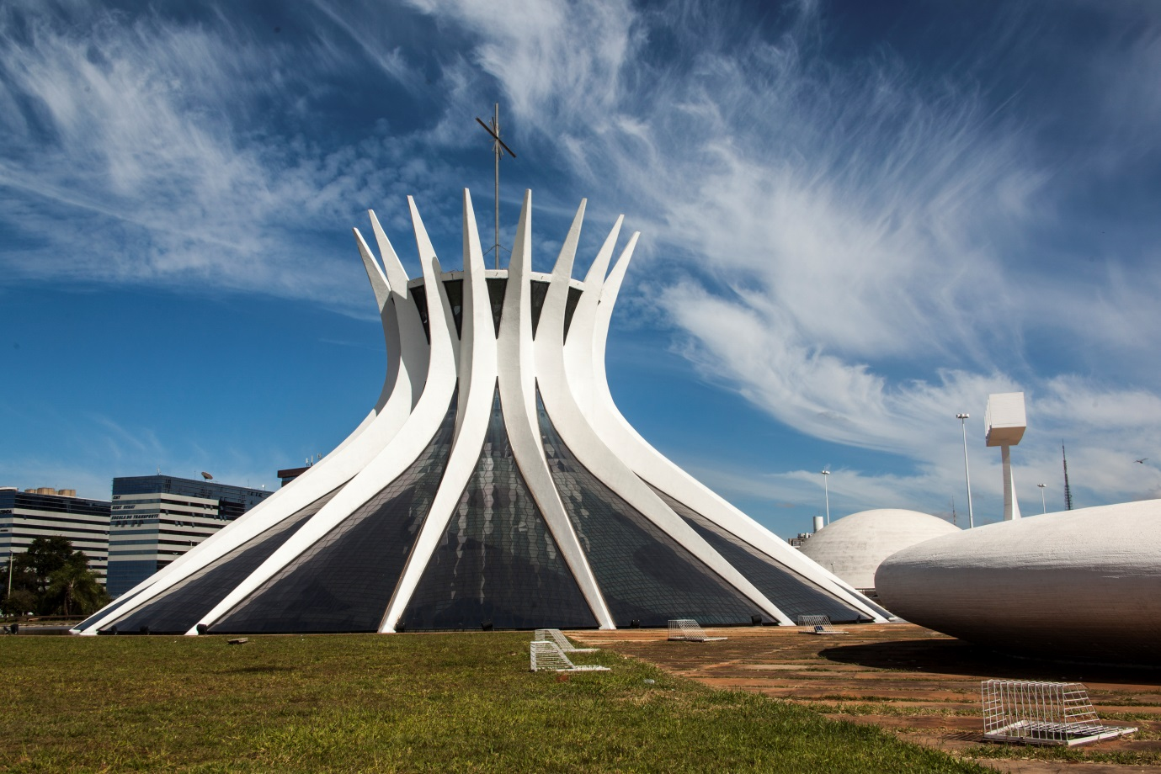

Catedral Metropolitana Nossa Senhora Aparecida (Cathedral of Brasília) (1958-59)

In the centre of [São Paulo](https://en.wikipedia.org/wiki/S%C3%A3o_Paulo), the Edifício Copan [apartment building](https://en.wikipedia.org/wiki/Copan_Building" \o "Copan Building) (1952–66) surpasses the monolithic typologies of modernism by allowing a wave-like form to disrupt the façade, and the resulting undulation is emphasized by the horizontal lines of a concrete brise-soleil. Domestic projects included a block of flats for the Interbau Exhibition in Berlin (Hansa Quarter, 1957) and, on a smaller scale, Niemeyer's own Canoas House outside Rio (1951-53), which presents a fascinating interplay between architectural and natural elements. The house is situated on sloped terrain overlooking the ocean, and shelters beneath a free-form roof supported on thin metallic columns.

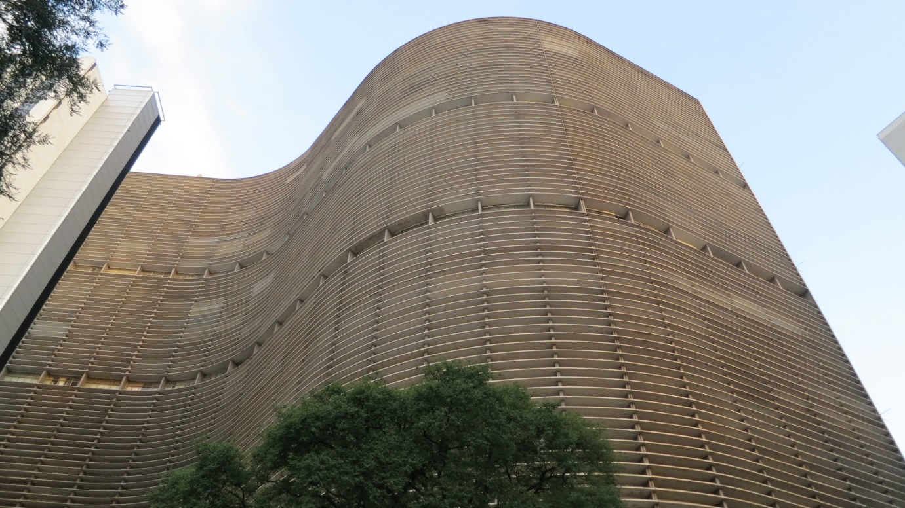

Edifício Copan, São Paulo (1952-66)

<http://a.com.gt/log/imgs/2013/04/edificio-copan.jpg>

Due to his leftist ideology and involvement with the Brazilian Communist Party, Niemeyer left the country after the military coup of 1964 and opened an office in Paris. During this period he designed a building for the French Communist Party in Paris (1965-80), where he collaborated with the renowned engineer Jean Prouvé. Notable works of this phase include the Mondadori Building, Milan (1968-76); the Bourse de Travail, Bobigny, Paris (1970-80), and the Maison de la Culture at Le Havre (1972-82). Niemeyer made a triumphant return to Brazil in 1985 and completed major projects including the Samba Stadium in Rio (1983-84), the Latin America Memorial and the Latin America Parliament Building in São Paolo (1989-92), and the Museum of Contemporary Art near Rio (1991). Niemeyer died in Rio de Janeiro on 5 December 2012, ten days before his 105th birthday.

**Selected Works**

1939 – Brazil’s pavilion at 1939 New York World's Fair, with Lucio Costa.

1940 – Church of St Francis of Assisi and other buildings at Pampulha, near Belo Horizonte.

1946 – Headquarters of Banco Boavista in Candelaria, Rio de Janeiro.

1952-66 – Edifício Copan (Copan Building), residential building, São Paulo.

1952 – Casa das Canoas – Niemeyer’s personal home, Canoas, Rio de Janeiro.

1954 – Museu de Arte Moderna em Caracas (Museum of Modern Art in Caracas).

1957 – Interbau buildings project in the Hansaviertel district, part of the reconstruction of Berlin.

1957 – Palácio da Alvorada (Palace of Dawn) Presidential residence, Brasília.

1958 – Catedral Metropolitana Nossa Senhora Aparecida (Cathedral of Brasília).

1958 – National Congress of Brazil.

1958 – Supremo Tribunal Federal (Supreme Federal Tribunal), Brasília.

1958 – Palácio do Planalto (Palace of the Highlands) Presidential office, Brasília.

1958 – Cláudio Santoro National Theater (National Theater), Brasília.

1960 – Praça dos Três Poderes (Square of the Three Powers), Brasília.

1962 – Ministério da Justiça (Ministry of Justice), Brasília.

1963 – University of Haifa, Israel.

1965-80 – French Communist Party headquarters, Paris.

1968-76 – Mondadori publishing headquarters, Milan.

1968 – Civic Center of Algiers.

1968 – Mosque of Algiers.

1972 – Labour council building of Bobigny, France.

1987–89 – Latin America Memorial, São Paulo.

1989-91 – Latin American Parliament, São Paulo.

2001–02 – Oscar Niemeyer Museum in Curitiba, Paraná.

2003 – Serpentine Gallery Pavilion, London.

**Further Reading**

## Hess, A. (2006) *Oscar Niemeyer houses*. New York: Rizzoli International.

Niemeyer, O. (2000) The Curves of Time: The Memoirs of Oscar Niemeyer. London: Phaidon.

## Niemeyer, O. (2008) [*Oscar Niemeyer: form & space*.](http://capitadiscovery.co.uk/northumbria-ac/items/1401778?query=niemeyer&resultsUri=items%3Fquery%3Dniemeyer) Tokyo: A.D.A. Edita.

## Philippou, S. (2008) [*Oscar Niemeyer: curves of irreverence*.](http://capitadiscovery.co.uk/northumbria-ac/items/1401779?query=niemeyer&resultsUri=items%3Fquery%3Dniemeyer) New Haven, Conn.; London: Yale University Press.

Salvaing, M. (2002) *Oscar Niemeyer*. New York: Assouline Publishing.